Lab # 8
Pandas


Spring 2026
Semester: 4th
AI-01L Programming for AI

Submitted by: Warisha Danin Bilal
Registration No: 24PWAI0004
Class Section: A

Submitted to: Ms. Kanwal Aneeq
June 9, 2026 2026

Bachelor of Science in Artificial Intelligence
University Of Engineering and Technology Peshawar

Task 1: Load Datasets
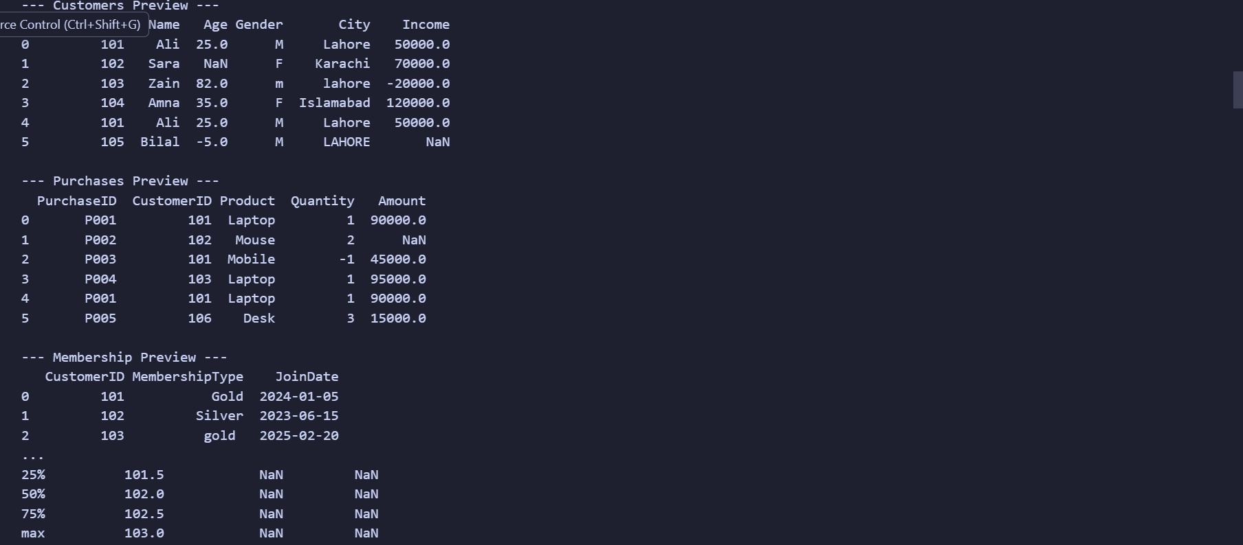
Task: Data Cleaning
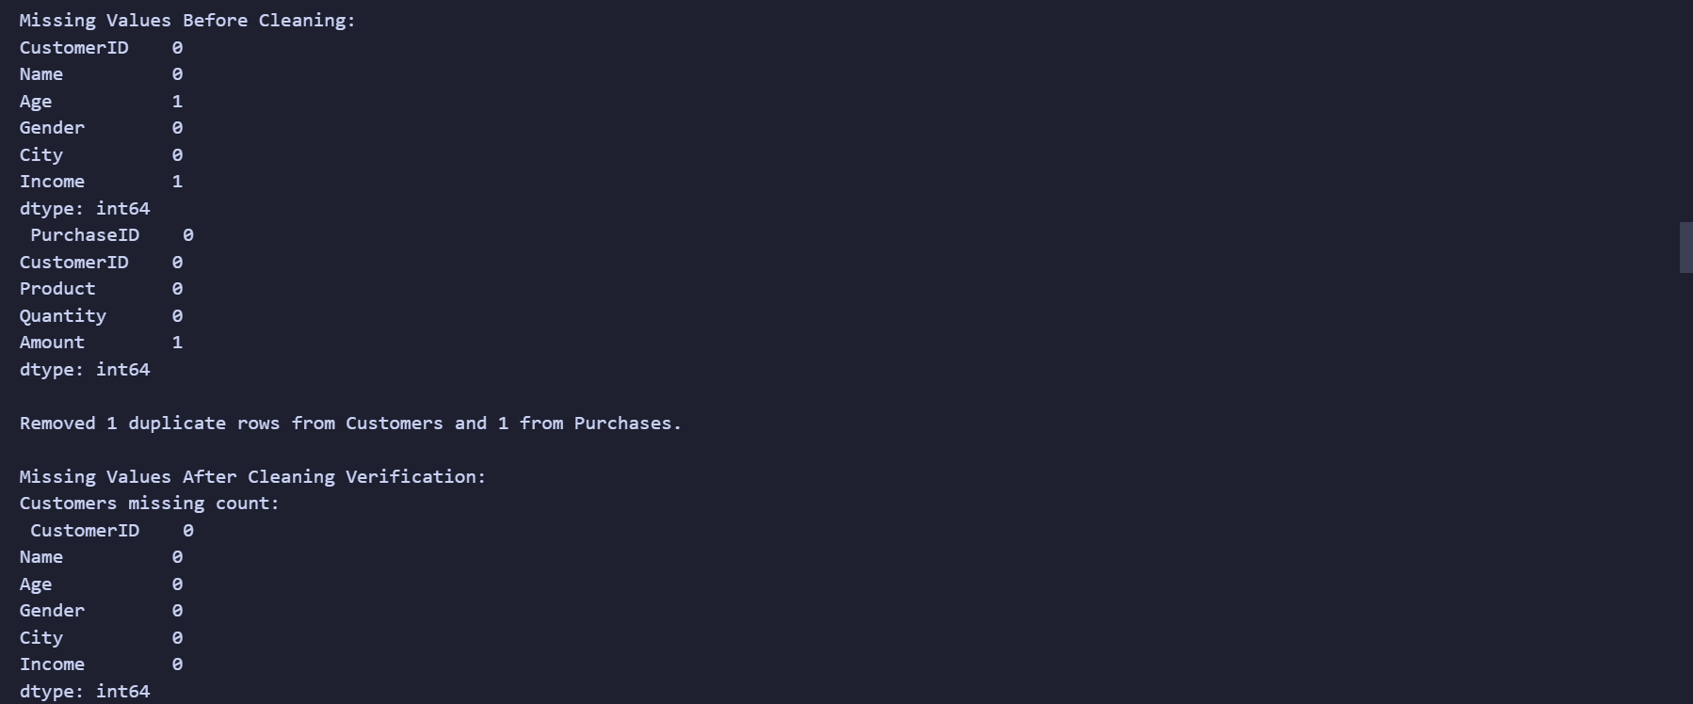
Task : Data Exploration and Filtering
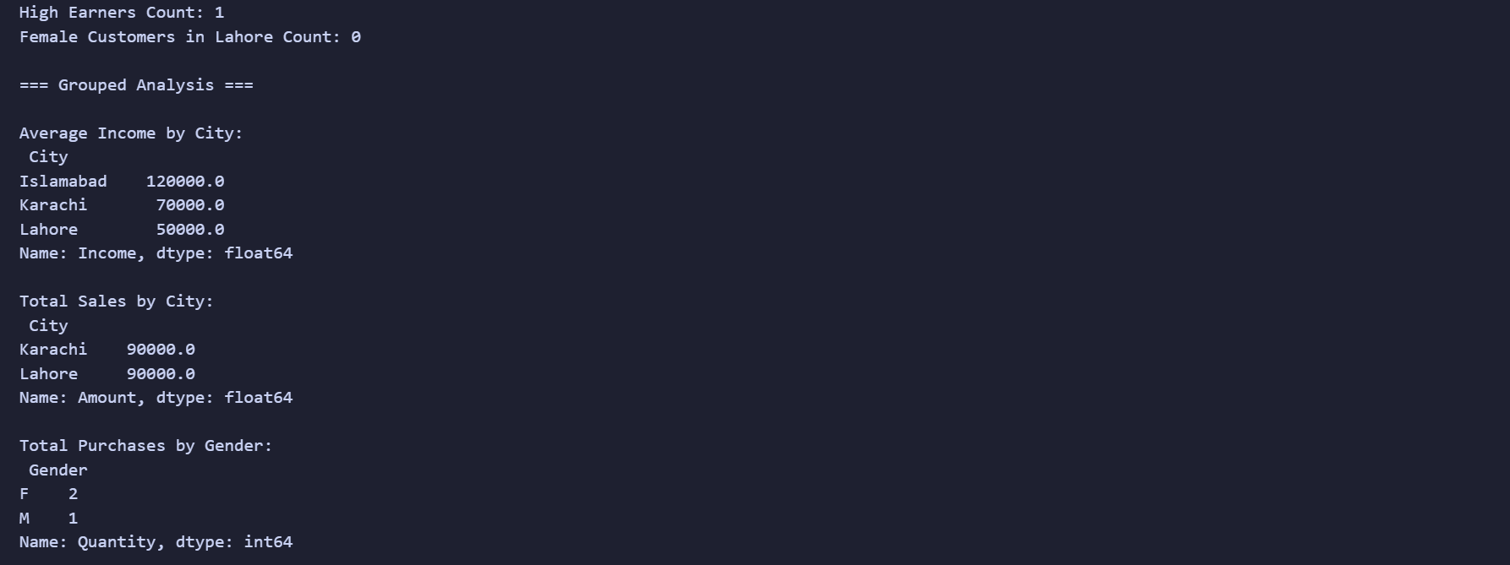
Task: Dataset merging
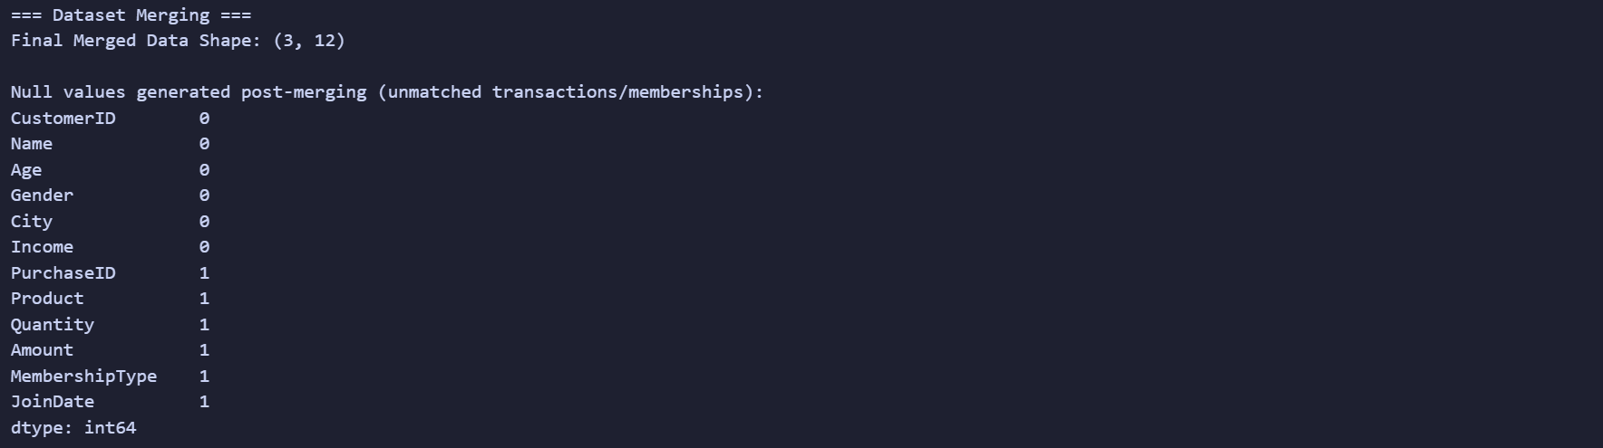
Task: Feature Engineering for AI
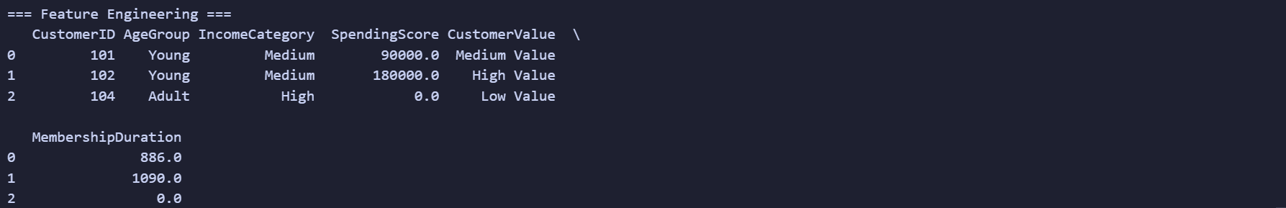
Task: Prepare Data for ML
